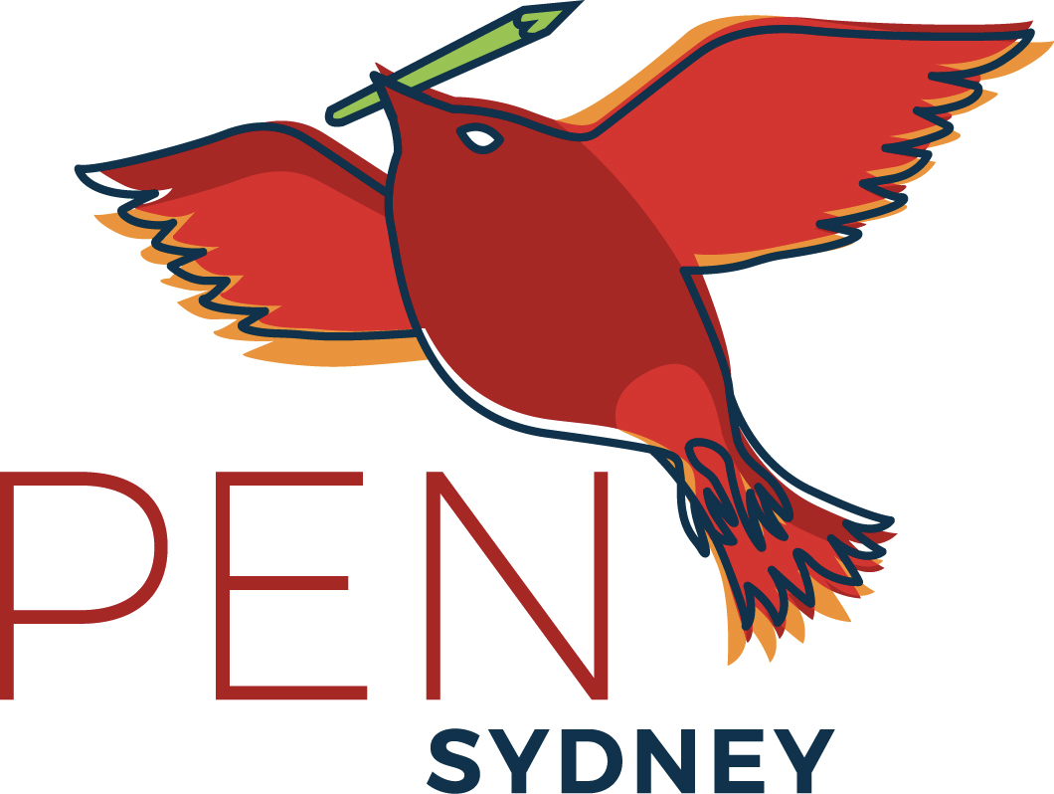
Sydney PEN Centre
c/- FASS, UTS
PO Box 123
Broadway NSW 2007
sydney@pen.org.au

1 September 2022

Re: Continuous imprisonment and transfer of Mr Kasra Nouri

His Excellency Mr Fereidoun Haghbin,
Ambassador of Iran Embassy of the Islamic Republic of Iran,
25 Culgoa Circuit,O’Malley,
ACT 2606

By email: amb.office@iranembassy.org.au

Dear Excellency

I am writing to you on behalf of PEN Sydney, an affiliate of PEN International, a worldwide organisation that defends freedom of expression and supports writers who are silenced by persecution or imprisonment.
We at PEN Sydney are deeply concerned about the mounting pressure on the Iranian journalist Mr Kasra Nouri created by transferring him to Shiraz for further interrogation under fabricated accusations.

Pourya Nouri, Kasra Nouri’s brother, stated in a tweet, “Kasra told my mother on the phone the reason for his transfer is a statement that does not exist!”
It was reported in 2019 by the Committee to Protect Journalists that “Iranian journalist Kasra Nouri is serving a 12-year sentence on anti-state charges in Adel-Abad prison near the central city of Shiraz. He was arrested in February 2018 while covering religious protests for the Majzooban-e-Noor website, which covers news about the Gonabadi Dervishes, a Sufi splinter group. Despite multiple requests for furlough from Nouri, his family, and his lawyer, he was not granted any temporary release during the coronavirus outbreak, and he contracted COVID-19 in June 2021.”
We believe these charges are unjust and in direct contravention of Article 19 of the International Covenant on Civil and Political Rights (ICCPR), which Iran has ratified.
PEN Sydney urges your government to immediately drop all fabricated accusations and charges against Kasra Nouri and release him from prison.
Further to this, PEN Sydney calls on The Islamic Republic of Iran to end their use of the legal system in persecuting writers, journalists and political prisoners held in prison for having exercised their rights to freedom of opinion and expression.
We trust that you will consider this letter seriously Excellency, and that you will pursue PEN Sydney’s request for your government to follow just and less punitive policies with regard to Iranian writers, who are held in high esteem by admirers of literature around the world.
We await with anticipation a positive response from you.

Yours sincerely
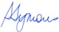
Dr Sandra Symons
President, PEN Sydney

